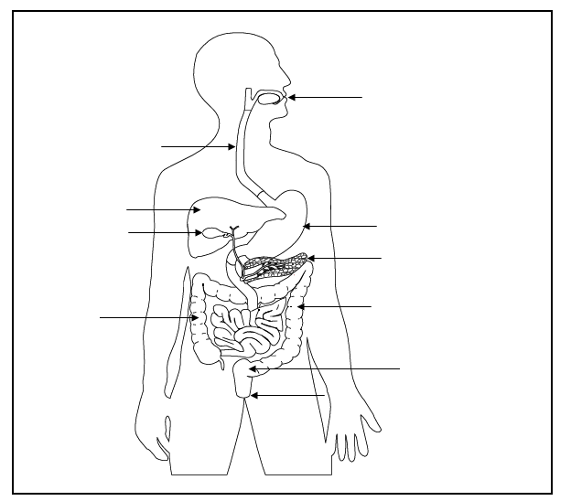
Anus - the opening at the end of the digestive system from which faeces (poo) leaves the body.
Oesophagus - the long tube between the mouth and the stomach.
Gall bladder - a small sac below the liver. It stores and releases bile into the small intestine.
Large intestine - the shorter wider tube that follows the small intestine.
Liver - a large organ which makes bile that neutralises stomach acid.
Mouth - the first part of the digestive system, where food enters the body.
Pancreas – a gland below the stomach which makes lots of chemicals called enzymes that help break down food.
Rectum - the lower part of the large intestine, where faeces (poo) is stored before it leaves the body.
Small intestine - the long, thin winding tube that food goes through after it leaves the stomach.
Stomach - a sack-like, muscular organ that is attached to the oesophagus. When food enters the stomach, it is churned with lots of acid.

Challenge : Use the descriptions of the digestive organs to correctly label the diagram above.

